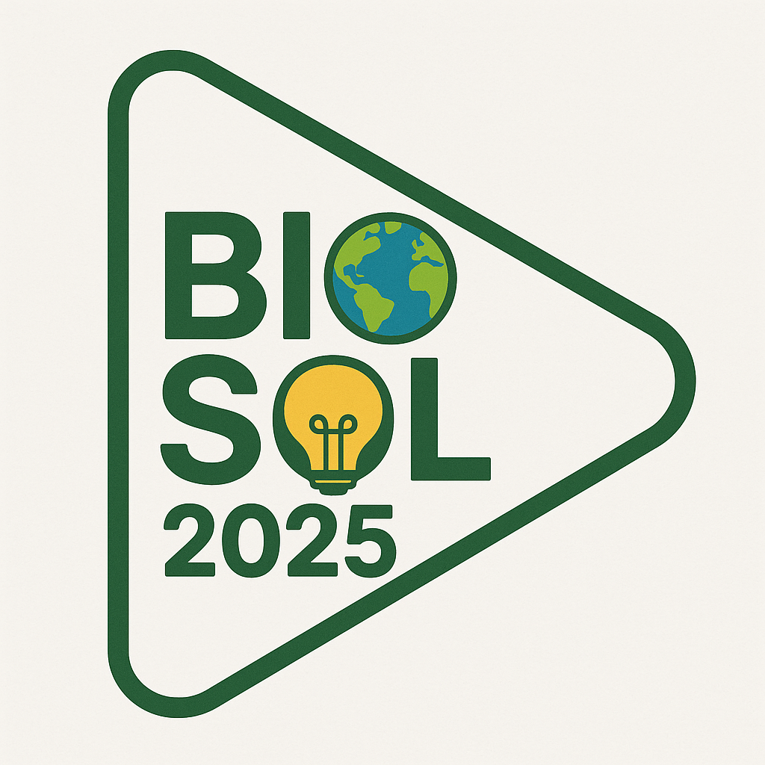
BIOSOL2025 Submission Form
Please complete the following and send the form along with your video submission and eligibility documentation to: biosol2025@ku.dk

1. Full Name: ___________
2. Email Address: ___________
3. Phone Number (with country code): ___________
4. Nationality/Nationalities: ___________
5. Academic Institution: ___________
6. Country of Academic Institution: ___________
7. Degree Program and Field of Study: ___________
8. Status (choose one):
☐ Final-year undergraduate student
☐ Recent graduate (completed undergraduate degree within the past year)
9. Date of Graduation (actual or expected): ___________
10. Title of Your Video Submission: ___________
11. Brief Description of Your Idea (max. 150 words): __________________________________________________________________________________________________________________________________________________________________________________________________________________________________________________________________________
12. Challenge Area(s) Addressed (select one or more):
☐ Valorising agro-industrial side streams
☐ Sustainable food production and preservation
☐ Microbial cultures to enhance nutrient absorption, bioavailability, and health benefits
☐ Bio-based production of renewable fuels and energy carriers
☐ Green chemistry and bio-based ingredients for consumer and industrial products
☐ Precision fermentation techniques (e.g., biomanufacturing of APIs)
☐ Production of alternative proteins
☐ Improving soil health
☐ Developing biofertilizers
☐ Plant varieties to mitigate and adapt to climate impact
☐ Biological alternatives to chemical pesticides and antibiotics
☐ Biological CO₂ capture, conversion, or reduction
☐ Waste biodegradation and circular bioeconomy solutions
☐ Biotech-based alternatives to fossil plastics
☐ Improving downstream processing for more sustainable biomanufacturing
☐ Biological water treatment
☐ Other

13. Does your video include any AI-generated images or content?
☐ No
☐ Yes – If yes, please specify the tool used: ___________

